**EXERCISE NUMBER :5 REGISTER NUMBER:RA2111026050026**

|  |  |
| --- | --- |
| **DATE** |  |
| **SUBMITTED BY** | **VISHNUPRIYAN S** |
| **TITLE / ROLE** | **Online Voting System** |

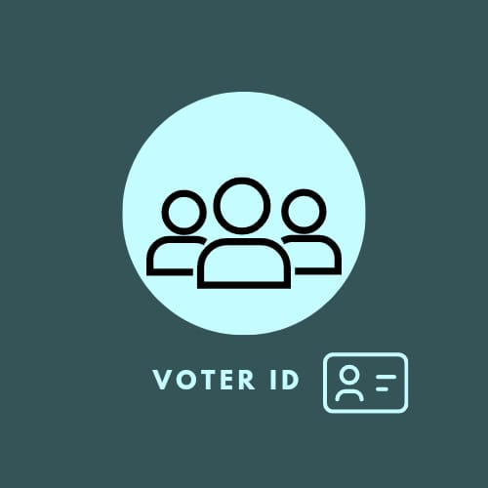

**Work breakdown structure based on timelines for developing an online e-voting system:**

**1.Planning Phase (1 month)**

Defining project scope, goals, and objectives

Creating a project plan

Identifying team roles and responsibilities

Conducting a feasibility study

Collecting requirements from stakeholders

Creating a requirements document

**2.Design Phase (2 months)**

Creating system architecture and design

Developing database schema

Designing the user interface

Identifying technical specifications

Developing security protocols

**3.Development Phase (3 months)**

Developing and testing the software

Building the database and server infrastructure

Integrating third-party software or tools

Creating and testing APIs and integrations

Conducting internal testing

**4.Deployment Phase (1 month)**

Deploying the online voting system to production environment

Conducting system testing in a live environment

Setting up user accounts and passwords

Performing system maintenance and updates

**5.Launch Phase (2 weeks)**

Communicating the launch date to stakeholders

Providing training and support to election officials and voters

Conducting a mock election to test the system

Addressing any issues that arise during testing

**6.Election Phase (1 day to several weeks depending on the type of election)**

Conducting the election

Monitoring the system for any issues or problems

Providing technical support to users during the election

Addressing any issues that arise during the election

**7.Post-Election Phase (1 month)**

Certifying the election results

Conducting an audit of the election results

Archiving the voting data and system logs

Conducting a post-election review to identify areas for improvement

Closing out the project and finalizing documentation

**Risk Management: -**

RMMM Plan: -

RMMM plan stands for the "Reduce, Manage, Maximize, and

Monitor" plan for personal finance management. Here is an

overview of how to implement this system:

1.Reduce: The first step is to reduce unnecessary expenses.

Review your expenses over the past few months and look for

any areas where you can cut back. This might include eating

out less often, cancelling subscription services you don't use,

or shopping for lower-cost alternatives.

2.Manage: The next step is to manage your finances

effectively. This means creating a budget and sticking to it,

tracking your expenses, and setting financial goals. Make

sure you're saving enough money each month, and consider

using tools like automatic savings plans or apps that help you

track your spending.

3.Maximize: Once you have reduced your expenses and are

managing your finances effectively, it's time to look for ways

to maximize your income and savings. This might include

investing in stocks or real estate, starting a side hustle, or

negotiating a raise at work.

4.Monitor: Finally, it is important to monitor your progress

and adjust as needed. Regularly review your

budget and spending to ensure you are staying on track, and

reassess your financial goals and investments to ensure they

align with your long-term plans.

Risk Table For Online e-voting Management System:-

| **Risk ID** | **Risk Description** | **Likelihood** | **Impact** | **Severity** | **Mitigation Strategy** |
| --- | --- | --- | --- | --- | --- |
| System error | Technical failure of the system | Moderate | High | High | Regular system maintenance and testing, backup systems, redundancy |
| Security Breach | Cyberattacks or system breaches | Low | High | High | Security protocols, encryption, multi-factor authentication |
| Regulatory Compliance | Non-compliance with regulations | Low | High | High | Compliance audits, legal review, adherence to relevant standards |
| User Error | Operational issues | Moderate | Moderate | Moderate | Contingency planning, redundancy, system monitoring |
| Human Error | Insufficient staff training | Low | Moderate | Low | Training programs, documentation, support resources |
| User Error | Inadequate user support | Low | Moderate | Low | User support services, help desk, FAQ, user manuals |